Day 01 Airport – Habarana

On Arrival at Colombo International airport you will be welcomed by our Chauffer guide. There after proceed to Habarana.

On route visit to the Pinnawela Elephant Orphanage.

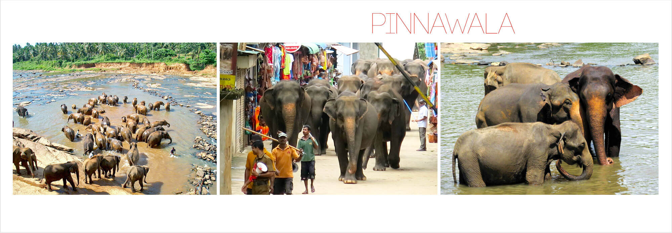

The town of Pinnawela near Kegalle, on the route to Kandy has become a vital stopover for most travellers who flock to visit the famed Elephant Orphanage. Begun in 1972, the Elephant Orphanage at Pinnawela is a remarkable project created to protect abandoned or orphaned wild elephants who would not otherwise have survived in the wild. Relocated to the present size in 1975, today it has grown to become one of Sri Lanka’s key attractions. The elephants roam free within the sanctuary – and the highlight of their (and the visitors’) day is the feeding sessions and when they are led down to the river for a bath. From the banks of the river you can watch these gleeful herds of elephants splashing around freely on the river.

And climb the sky fortress of Sri Lanka, Sigiriya in the eve.

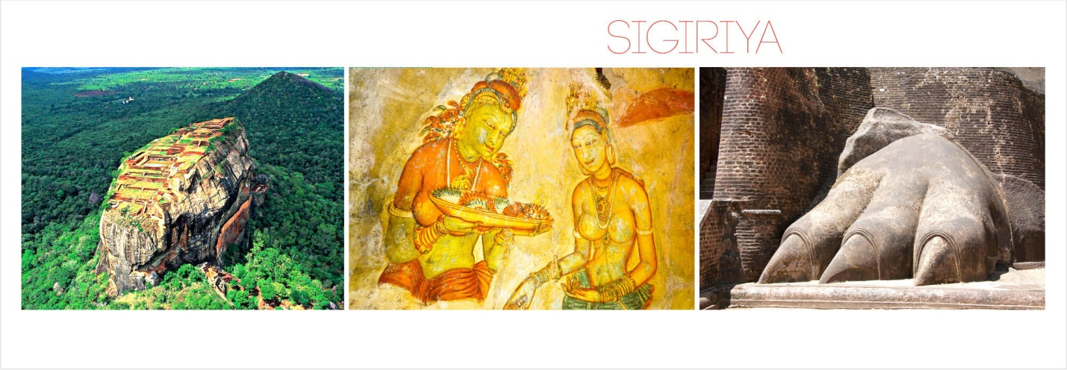

The ultimate icon of Sri Lanka’s historic past, the giant rock fortress of Sigiriya arises high above the flat landscape, surrounded by jungle on all sides. A testimony to the inventiveness of the ancient civilizations of the land, the once impenetrable stronghold of King Kassapa, ‘Sihagiri’ or Lion’s Rock as it was called then, is considered to be the 8th wonder of the world today. The feats of artistry, architecture and engineering at Sigiriya continue to impress visitors with their utter magnificence, even thousands of years on. Intricately landscaped pleasure gardens sprawl out below the rock, giant lion paws hewn in stone mark the entrance to the fortress at its foot, a highly polished mirror wall still carries the scrawled writings of ancient poets.

**Dinner & Overnight stay at Habarana.**

Day 02 –Habarana

**Breakfast.**

Go on a safari in the Minneriya National Park.

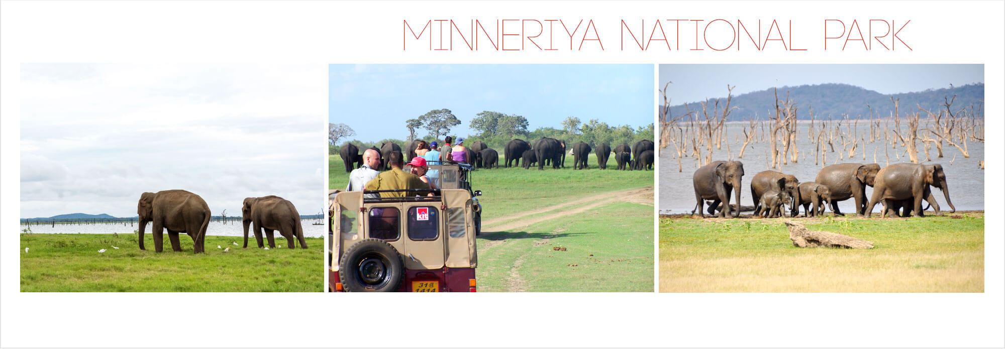

The Minneriya National Park encompasses the ancient Minneriya Tank which was built in the 3rd century AD by King Mahasen. Today, the ancient reservoir fills during the North Eastern monsoon, but gradually shrinks as the dry season approaches. During this time herds of majestic Asian Elephants, sometimes over 300 in number, converge onto the receding shores of the Minneriya tank to forage on the surrounding greenery. This unique phenomenon is the highest concentration of wild Asian Elephants on Earth and has come to be known as “The Gathering”. This phenomenon peaks during the months of August and September which is the height of the drought and is an opportunity not to be missed by wild life enthusiasts and casual travellers alike.

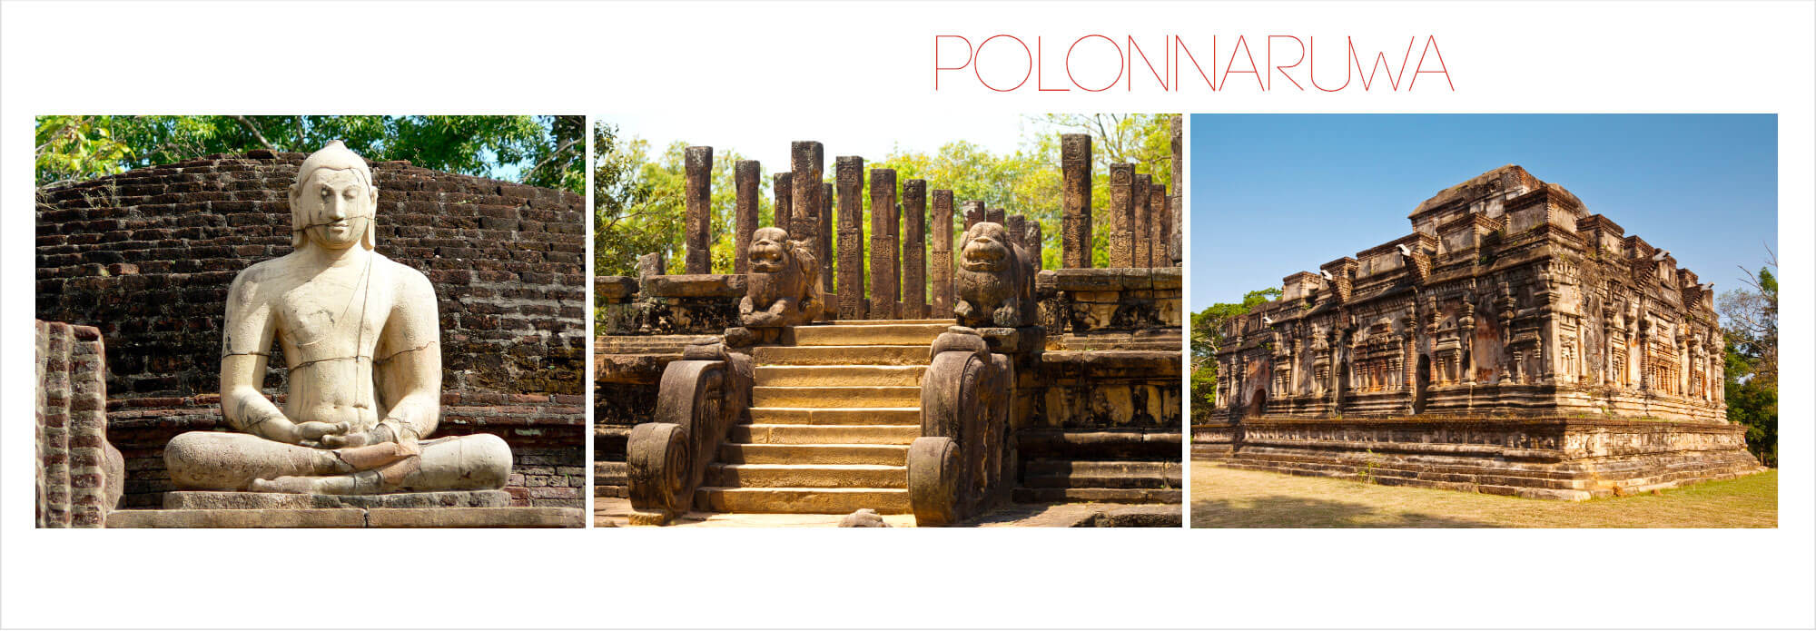After which a tour of timeless ruins of Polonnaruwa is arranged.

One of the most significant kingdoms in Sri Lankan history this medieval capital (11th - 12th Century AD) remains a well-preserved city of ancient stupas, moonstones, beautiful parks, massive buildings and imposing statues. The ruins of this ancient city stay scattered over an extensive area of woodland and can be explored within a day. The city was enclosed by three concentric protecting the royal palace complex at its center, the religious buildings - called Quadrangle, lie to the North and are very well preserved to this day. The largest monuments are found here including the buildings of the Menik Vihara, Rankot Vihara, Alahana Pirivena and Jetavana monasteries, the incredible Buddha statues of the Gal Vihara, the soaring Lankatilaka shrine, the majestic King's Council Chamber, the Lotus Bath are must see sights. And of course, the giant statue of Polonnaruwa's greatest king - Parakramabahu, and the vast ‘Sea of Parakrama’ – a 12th century man-made reservoir which dominates the city are not to be missed either.

**Dinner & Overnight stay at Habarana.**

Day 03 – Habarana - Kandy

**Breakfast.**

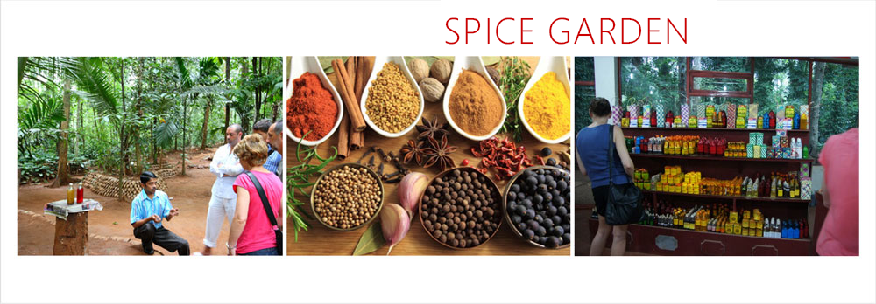Proceed to Kandy. On the way to visit a spice garden in Matale

And in the evening walk in the Royal Botanical Garden of Peradeniya.

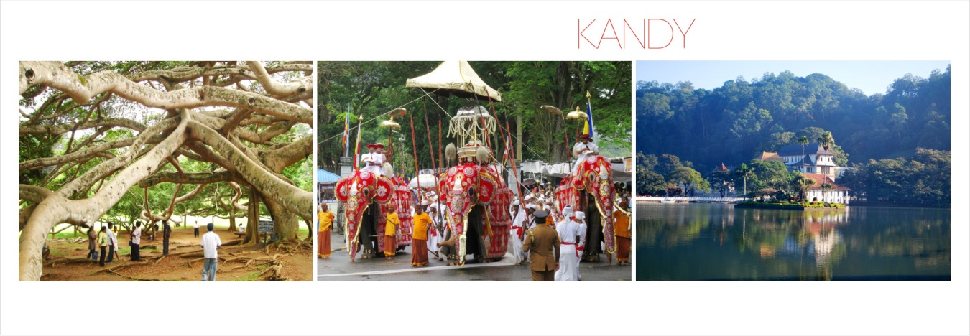

The cultural epicenter and the hill capital of the island, Kandy is Sri Lanka’s second city and home to the Temple of the Tooth - the country’s most important religious shrine, and the traditional pageant the Esala Perahera. Although modernity and urban sprawl has changed the face of this once quaint hill station, it still carries a regal atmosphere with graceful Kandyan style architecture mingling with colonial buildings set around a tranquil lake surrounded by green hills. The kingdom of Kandy was the last stronghold of the Sinhalese, clinging to its sovereignty long after the island had fallen to the Portuguese and Dutch and the English, preserving its own unique customs and culture until the very last.

**Dinner & Overnight stay in Kandy.**

Day 04 – Kandy

**Breakfast.**

Spend the day in leisure, or take part in the following excursions.

Visit the scared Temple of tooth, which houses the sacred relic of Lord Buddha.

Following a visit to Silk Factory and the Gem Museum in Kandy.

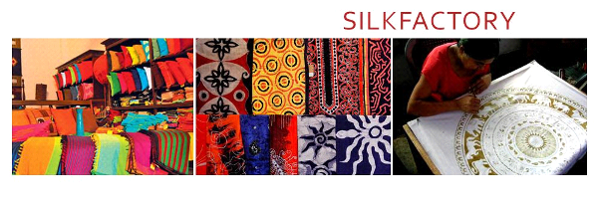**Dinner & Overnight stay in Kandy.**

Day 05 – Kandy – Nuwara Eliya

**Breakfast**, leave for Nuwara Eliya.

On the way visit the Tea Factory Planation to witness the process how the world famous Ceylon Tea is being made.

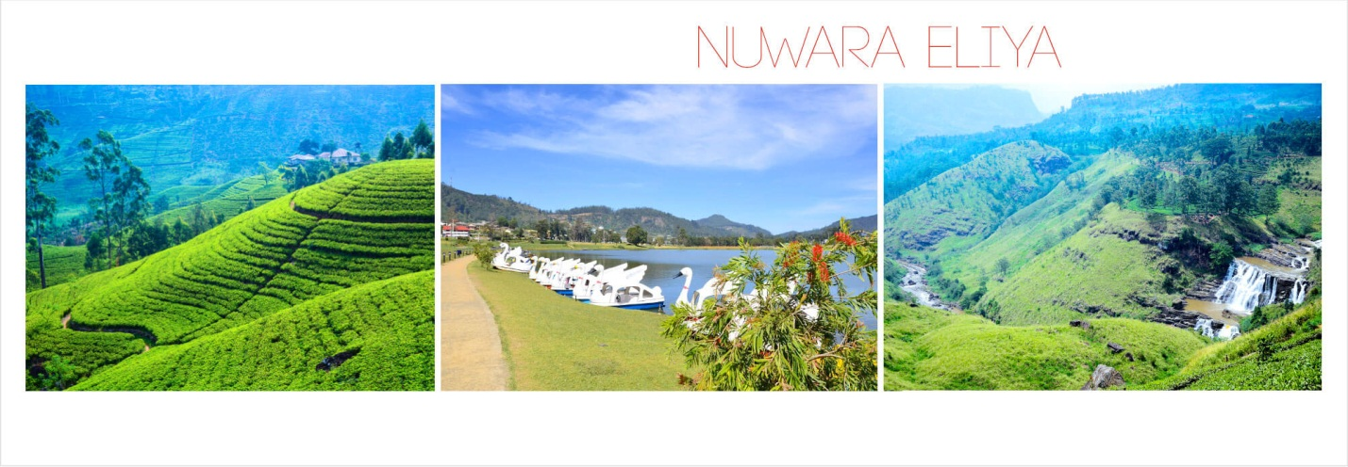

Hidden away high in the central mountains at an altitude of over 6000 feet, Nuwara Eliya is the resort capital of the hills – and a world away from the hot tropical beach atmosphere of the coast, not just in climate but in its character too. The British planters who flocked to the region to grow tea in the mid-19th century developed Nuwara Eliya as their summer retreat. Created as an exact replica of an English town it is often called ‘Little England’; and with its primarily colonial architecture, the stately Victoria Park, golf course, racing track, boating lake and grand period style hotels – and the cold, frequent showers of rain adding to the illusion, you could well be in an old English country town. This is the heart of the tea country, and is also a good base for excursions to discover other attractions of the hills.

**Dinner & Overnight stay in Nuwara Eliya**

Day 06 – Nuwara Eliya – Horton Plains - Nuwara Eliya

**Breakfast.**

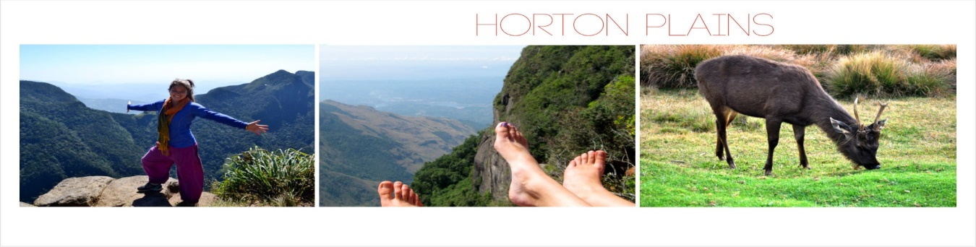In the morning, visit to [Horton Plains National Park](http://getawaysrilanka.com.au/hortonplains). (Kindly note the Trekking will be 04 per way)

A truly unique natural wonder, Horton Plains National Park is a protected reserve of montane grassland and cloud forest in the central highlands at an altitude of 2,100–2,300 meters (6,900–7,500 ft.), located around 28km from Nuwara Eliya in the central hills. The highest plateau in Sri Lanka it ends dramatically with a sheer drop of 870 m (2,854 ft.) called World’s End, which offers most spectacular views on a clear day. The reserve is a biodiversity hotspot with many endemics; myriad bird species, herds of Sambur deer, bear monkeys and the elusive leopard. Back to the Hotel and spend the day at leisure.

Back to the Hotel and spend the day at leisure.

**Dinner & Overnight stay in Nuwara Eliya.**

Day 07 – Nuwara Eliya –Yala

**Breakfast**

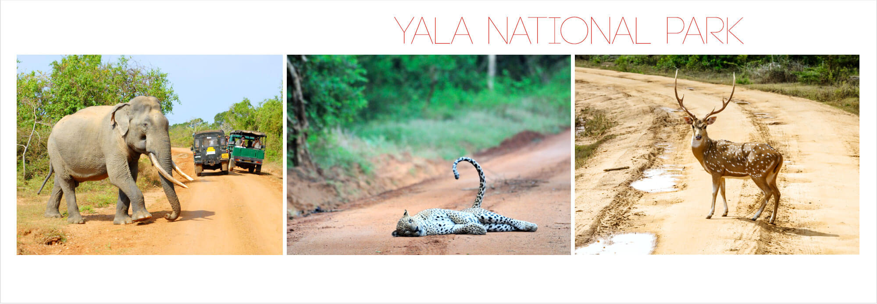Leave for Yala and check in to the Hotel.

Situated in the arid South East region of Sri Lanka, Yala National Park is home to the greatest variety of the nation’s wildlife and therefore, its most popular wildlife destination. Declared a Game Reserve in 1938, Yala comprises five blocks covering an area of 151,778 hectares. The park comprises several major habitat types - dunes, scrub forest, riverine forests, rocky out-crops, secondary forests and coastal lagoons with mangrove forests which are home to a wide variety of wildlife. The 44 mammal species found here includes the endangered leopard sub-species *Panthera pardus kotiya*, which found only in Sri Lanka. Yala is also known to contain the highest Leopard concentration in the world. Other ‘big game’ such as sloth bear, herds of elephants, buffalo, sambar, spotted deer and crocodiles are also found in great numbers.

**Dinner & Overnight stay in Yala.**

Day 08 –Yala

With packed breakfast do the jeep safari in Yala National Park.

Back to the hotel and at leisure.

**Dinner & Overnight stay in Yala.**

Day 09 –Yala – Galle – Ahungalle Beach extension.

Breakfast.

Proceed to Bentota you can do the following excursions OR you can stay leisure on the beach.

On the way visit the Dutch Fort of Galle as well as the National Maritime Archeological Museum.

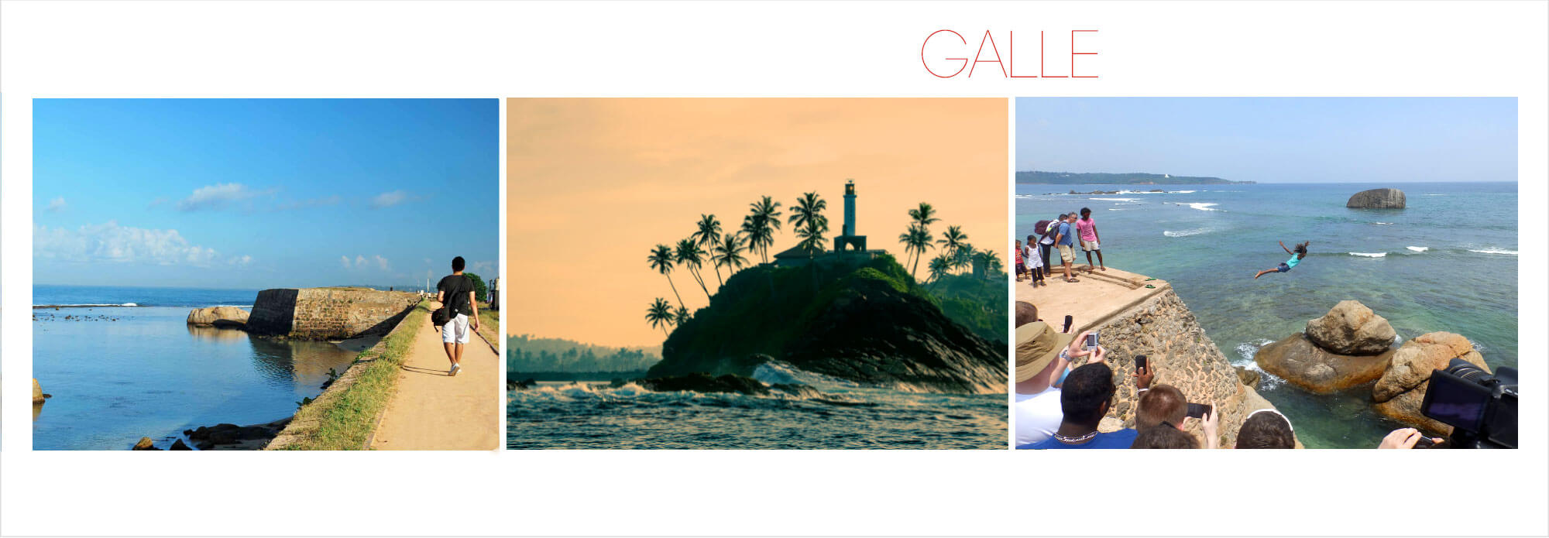

The new hub of ‘cool’ and creative activity in Sri Lanka, the Southern capital of Galle is enjoying a great comeback. Galle and its outskirts have now become a favored hotspot for travellers looking for an all-round holiday. The main attraction of Galle is the 17C Dutch Fort, a UNESCO protected World Heritage site. Historically, Galle was a location of paramount importance due to its strategic location on the South coast as well as its natural harbor. The center of ancient trade in gems, pearls, spices and more Galle was the port of call for many seekers of tropical treasure.

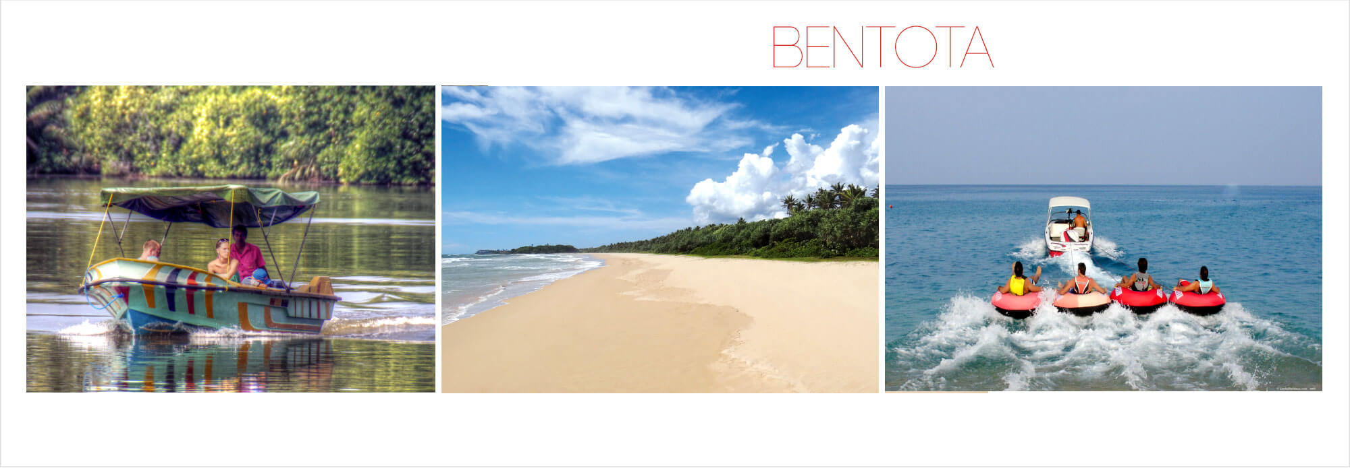

Bentota is a famous coastal town situated approximately 65 km south of Colombo and a tourist hotpot with a local airport and a handful of World Class hotels right on the beach including the lower and budget categories. It is a destination for water sports such as jet skiing, deep sea and river fishing, banana boat rides, river cruises...etc., to name a few. It is an ideal place for a sea swim or if you just want to sit out in the sun reading a book.

**Overnight stay in Bentota.**

Day 10 – Ahungalle

**Breakfast.**

Spend the day in leisure or following excursions are available as (**OPTIONAL**.)

Proceed to Balapitiya for river cruise.

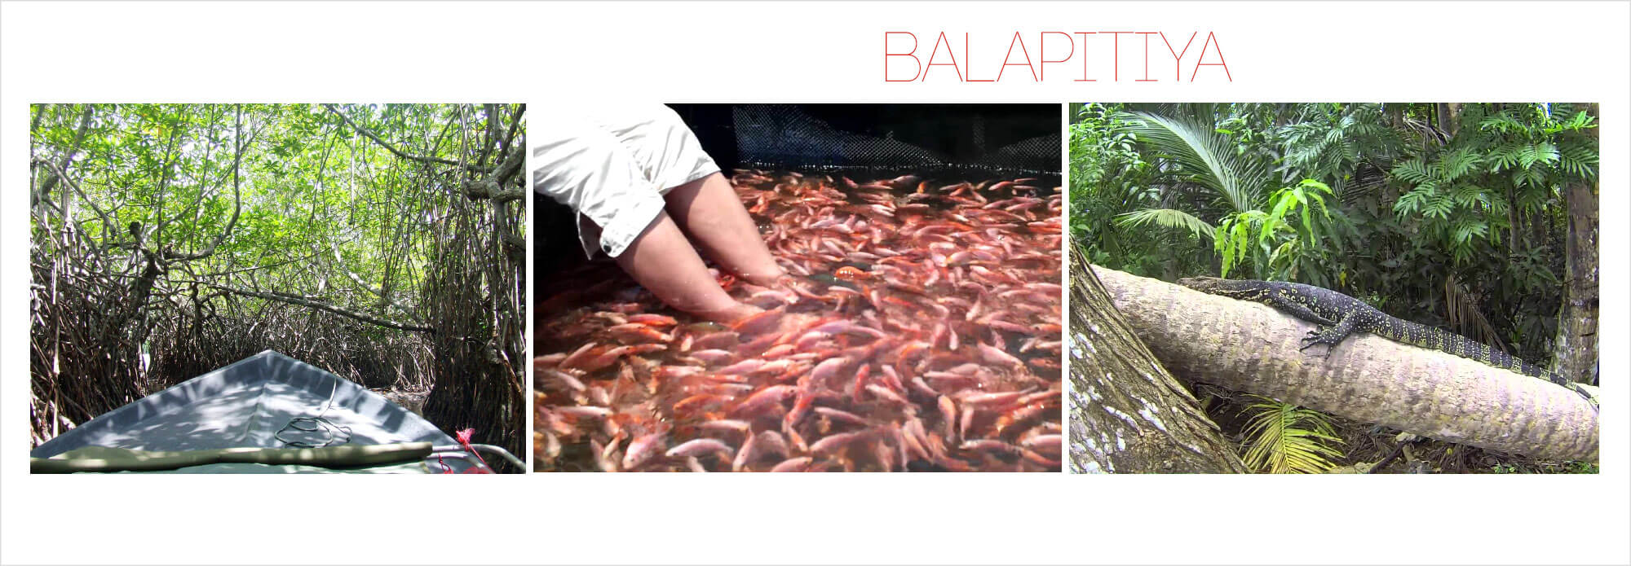

Balapitiya is a picturesque coastal town, located in the Southern Province in Sri Lanka. It is the nearest town to the infamous Maadu River. The town has many dated mansions and villas which are now transformed into attractive boutique villas and hotels, which makes finding suitable accommodation pretty easy. Surfing and snorkeling facilities are available and even deep sea fishing trips can be enjoyed.

One of the main attractions is the Maadu River safari. Maadu River which flows across Balapitiya, boasts of having many small islands most of which are uninhabited and covered with mangroves. With its variety of flora and fauna, it is fast becoming a popular spot for ECO tourists and bird watchers alike

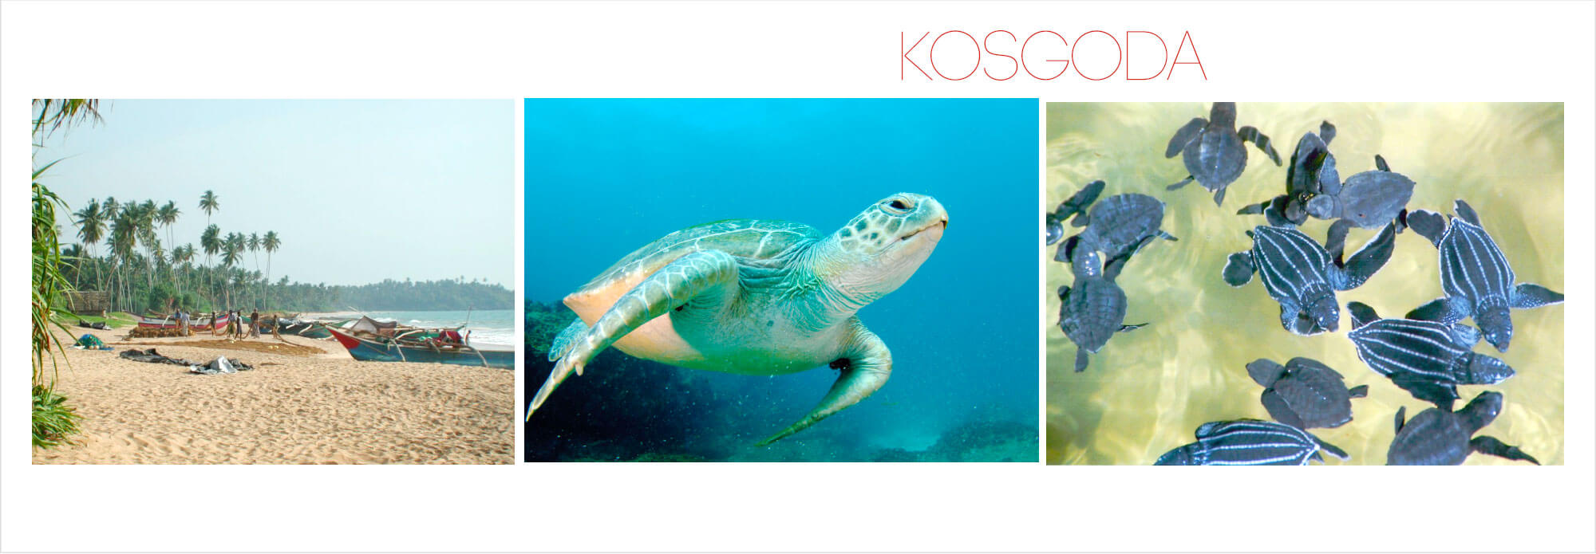On route visit Kosgoda turtle hatchery. (**OPTIONAL**.)

**Overnight stay in Bentota**

Day 11 – Ahungalle

**Breakfast**

Spend the day out in the sun and the sand.

**Overnight stay in Bentota**

Day 12 – Ahungalle – Airport

**Breakfast.**

Departure transfer to the airport. (Depending on the Departure Time)

******End of Services******